Math 10

Lesson 7-1 Answers

**Lesson Questions**

**Question 1**

a)



b)



**Question 2**



**Question 3**

Q

4.0 (adj)

5.0 (hyp)

adj and hyp → cos



**Question 4**



**Assignment**

1. a) 

b) 

c)

d)

2. a) 14° b) 51°

c) 68° d) 87°

3. a) 27° b) 45°

c) 61° d) 69°

4. Sketches will vary. For example:

a) 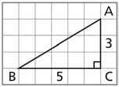

b) 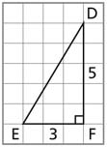

c) 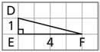

d) 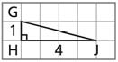

5. a) 36.4° b) 68.0°

6. a) 36.0° b) 49.1°

7. a) 11° b) 14° c) 6° d) 9°

8. 22°

9. 22°

10. 146°

11. a) There is no least possible value; the tangent can be arbitrarily close to zero.

b) There is no greatest possible value; the tangent can be arbitrarily large.

12. a) 

b) 

13. a) i) Opposite: GH; adjacent: AG; hypotenuse: AH

ii) Opposite: TK; adjacent: AK; hypotenuse: AT

b) i) sin A = 0.60; cos A = 0.80

ii) sin A = 0.28; cos A = 0.96

14. Sketches will vary. For example:

a) 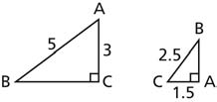

b) 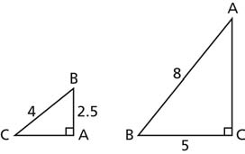

c) 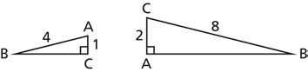

d) 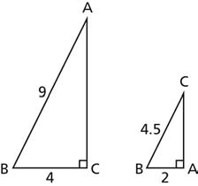

15. a) C = 16.3°, D = 73.7°

b) F = 63.9°, H = 26.1°

c) J = 38.0°, K = 52.0°

d) P = 49.3°, Q = 40.7°

16. 1.3°

17. 79.4°

18. 61°

19. 31°

20. a) i) 0.1736… ii) 0.3420…

iii) 0.6427… iv) 0.7660…

v) 0.8660… vi) 0.9848…

21.

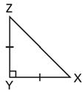

The opposite and adjacent sides of an acute angle have the same length, so

